*Junit Test*

**I. Booking**

1. testGetAllBookings

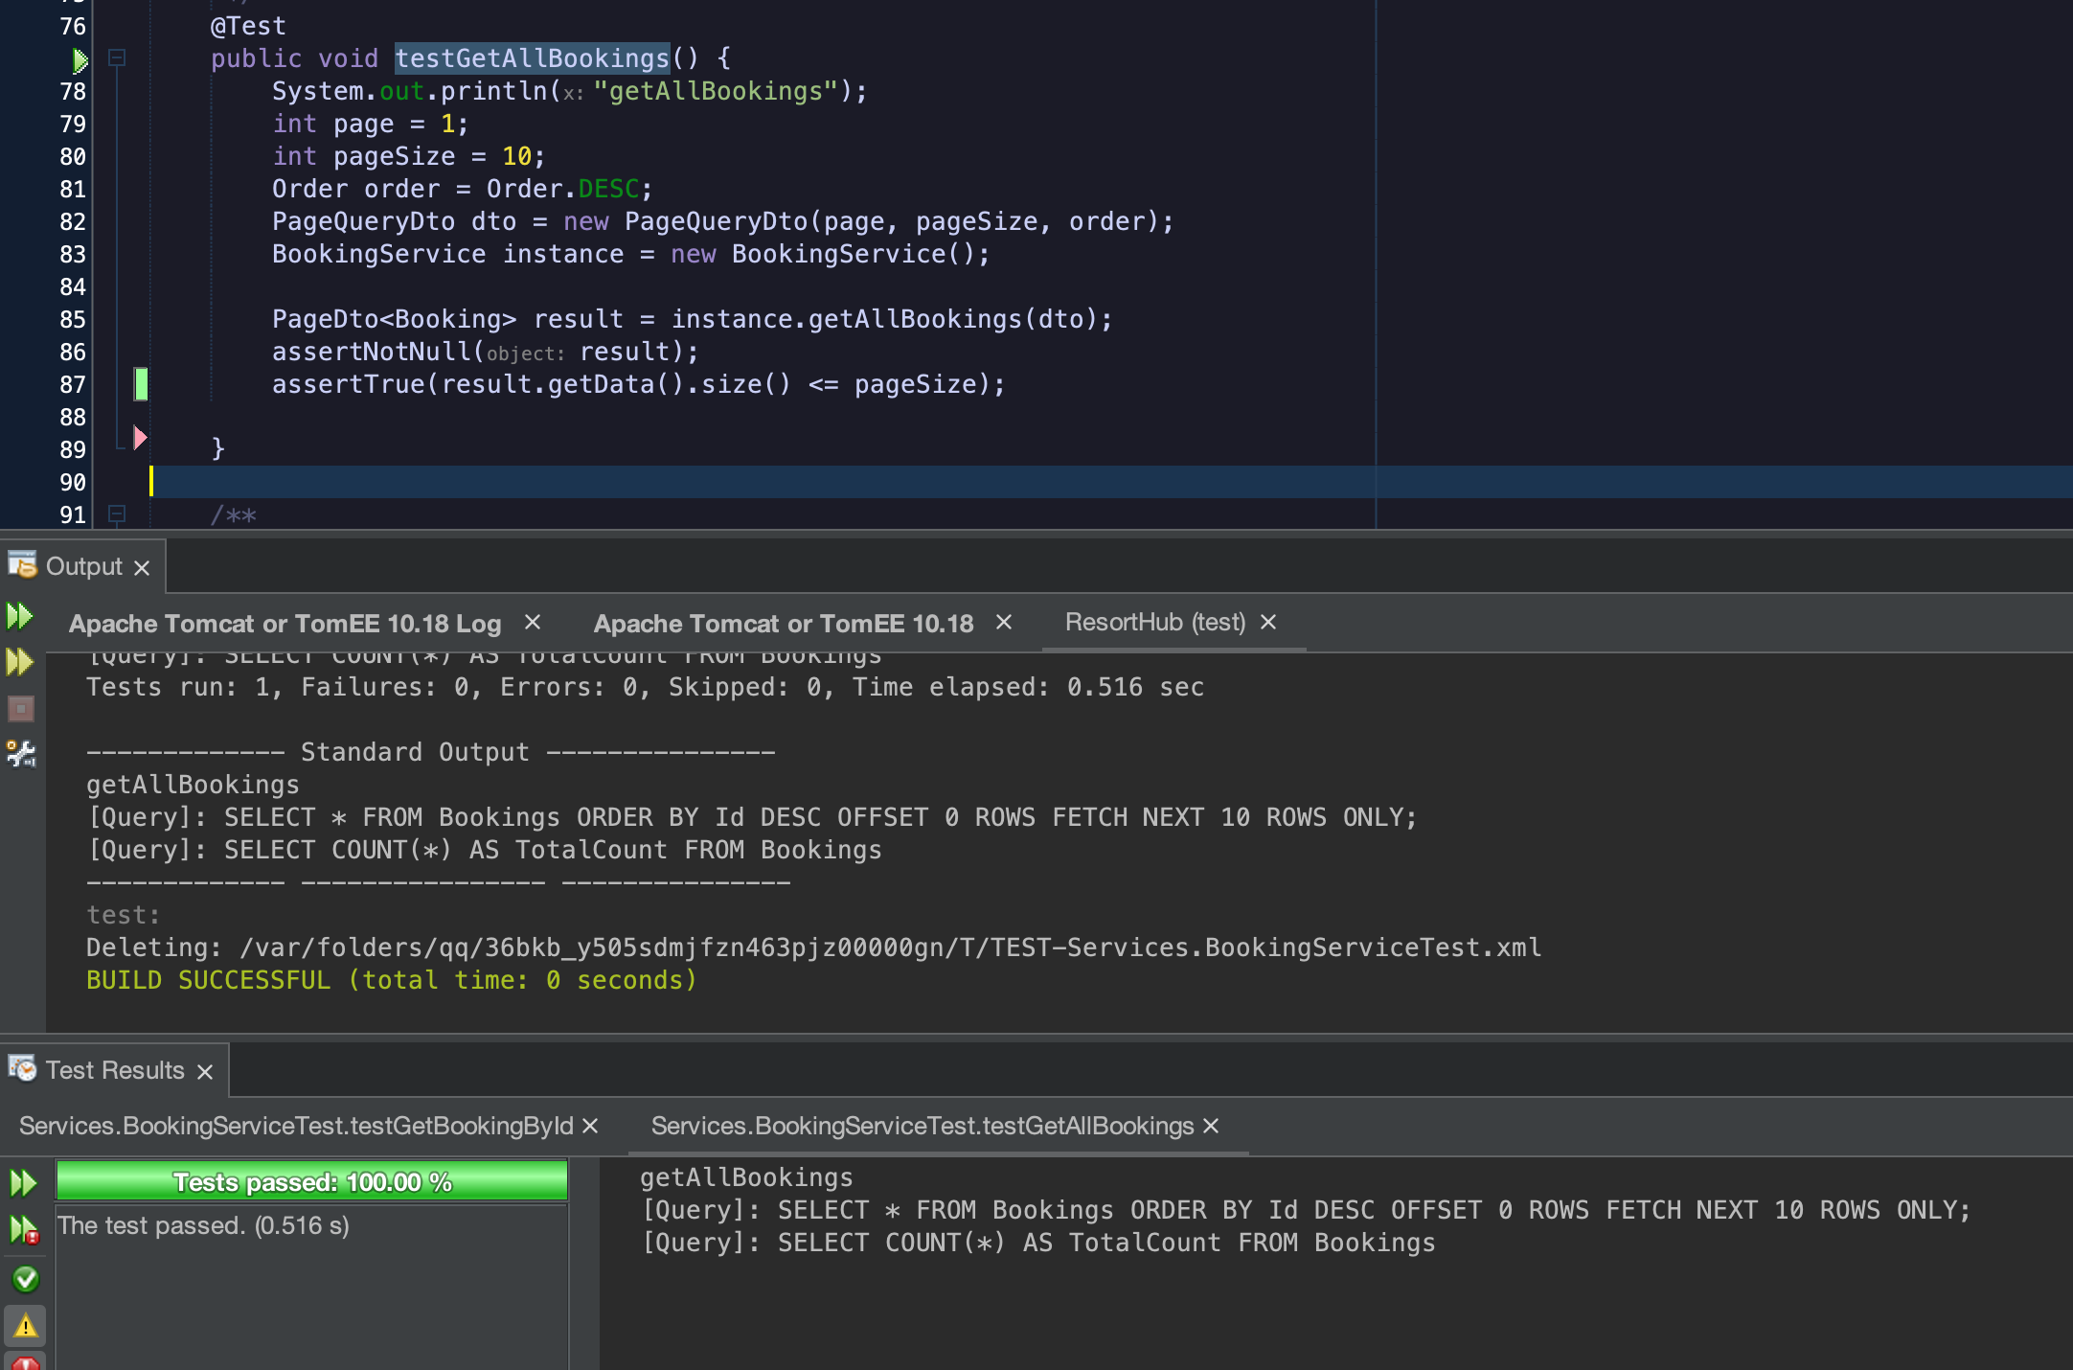

2. testGetBookingById

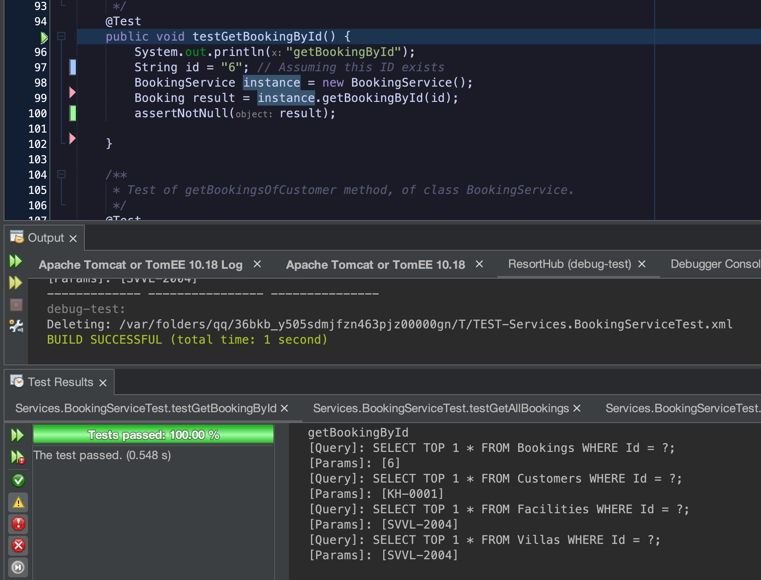

3. testGetBookingsByYear

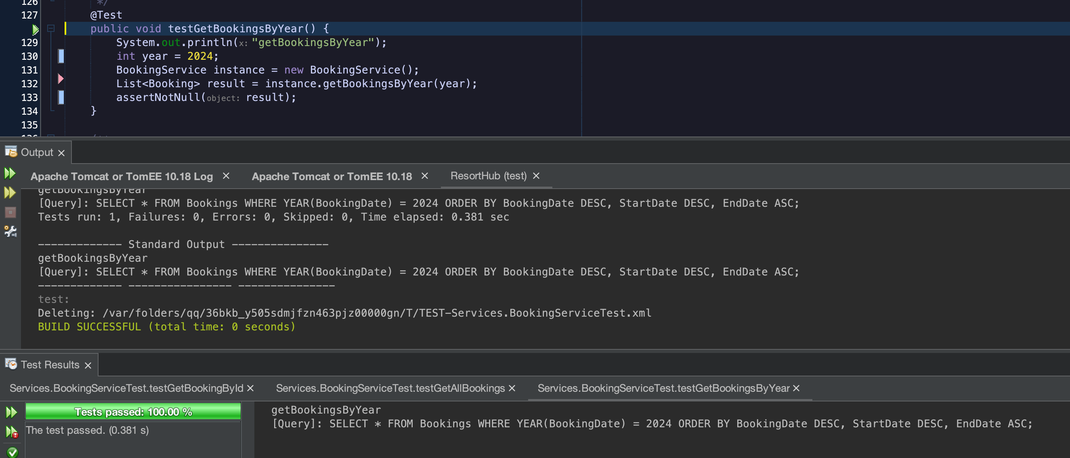

4. testGetBookingsByYearAndMonth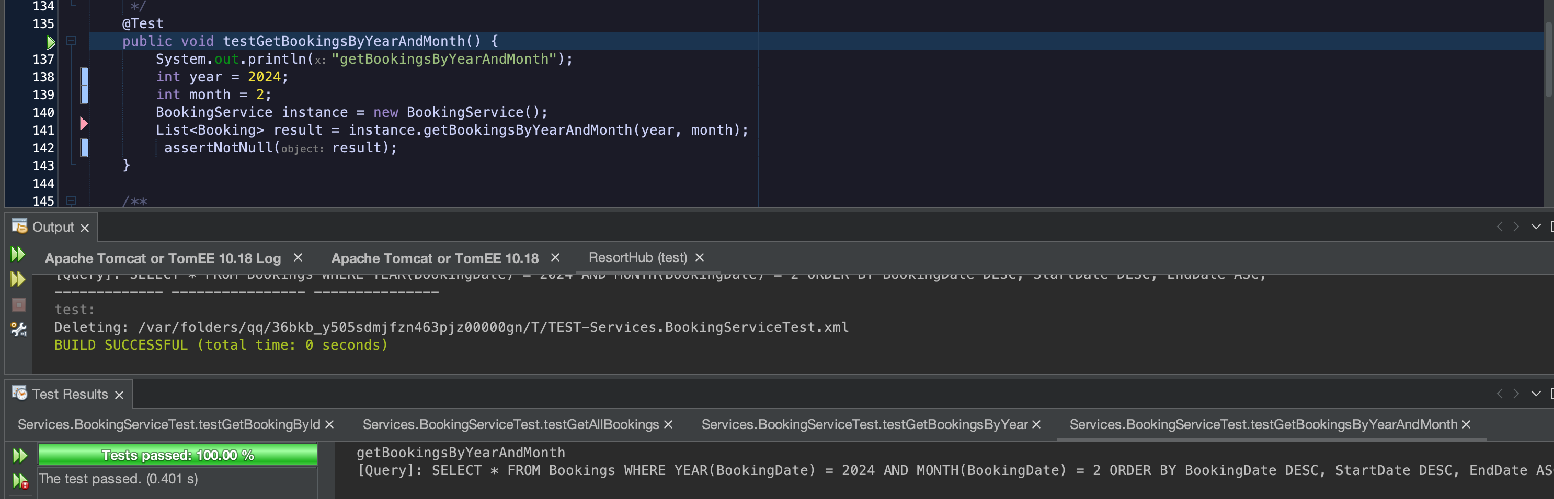

5. testCreateBooking

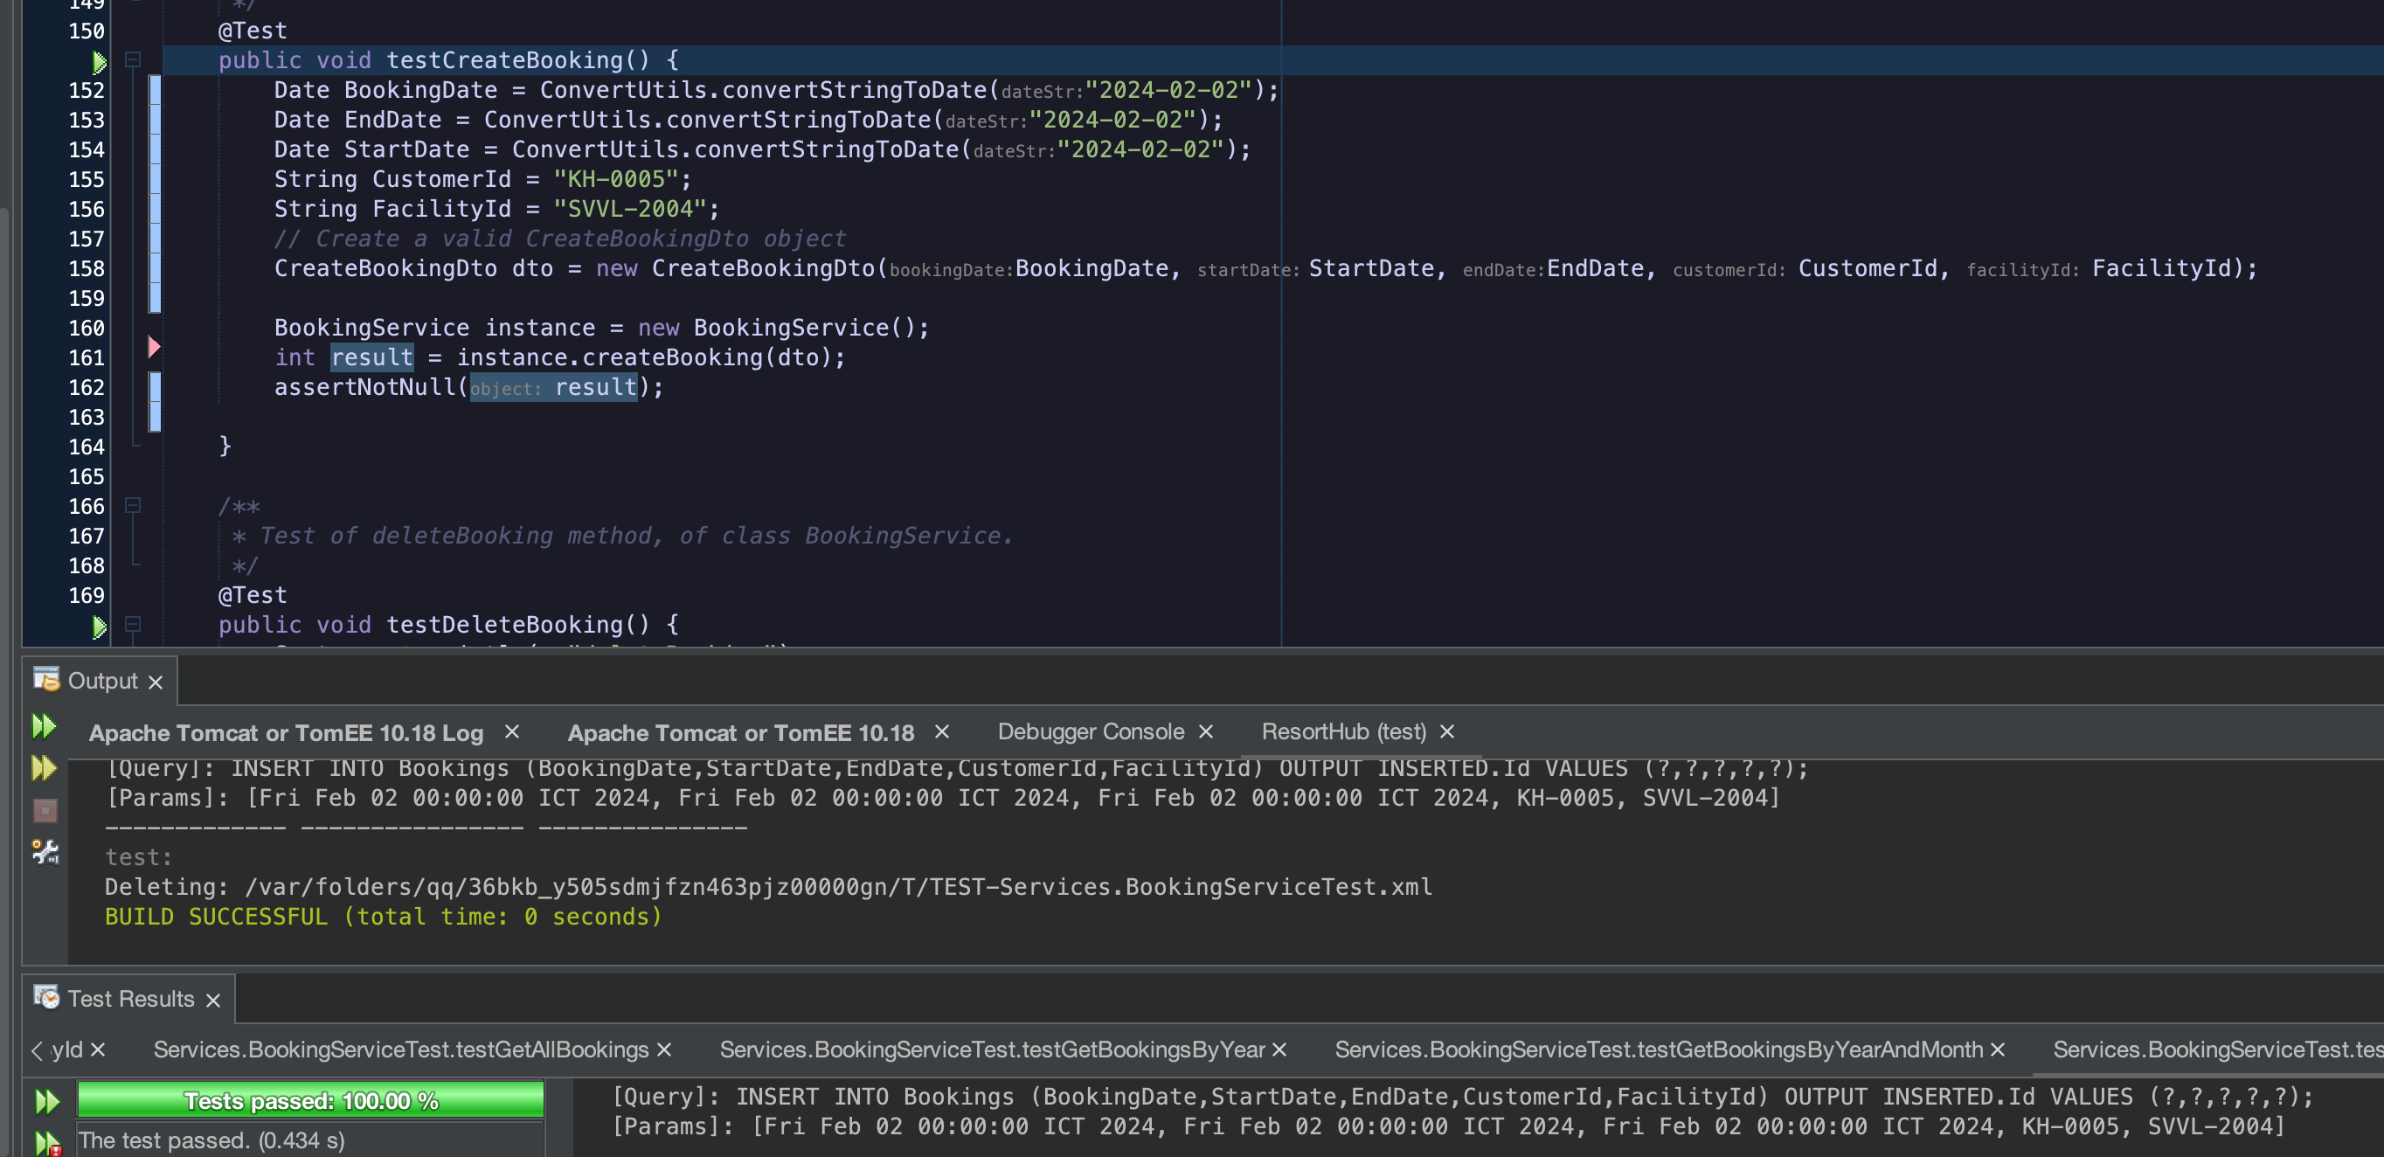

**II.Promotion**

1. testGetVoucherRecipientCustomers

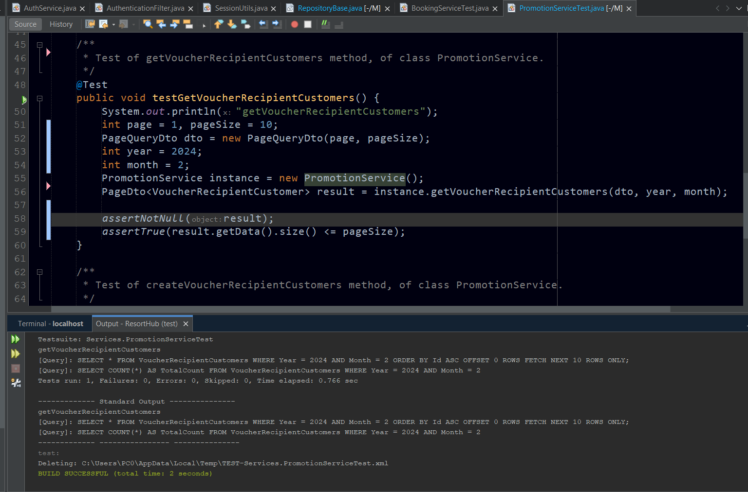

2. testCreateVoucherRecipientCustomers

